How Car Steering Works  by Karim Nice  ››Tell a friend about this article! |  | › Introduction to How Car Steering Works  › Turning the Car  › Rack-and-pinion Steering  › Recirculating-ball Steering  › Power Steering  › The Future of Power Steering  › Lots More Information!  › Search Google  › Shop or Compare Prices  › What do you think?
You know that when you turn the steering wheel in your car, the wheels turn. Cause and effect, right? But a lot of interesting stuff goes on between the steering wheel and the tires to make this happen.
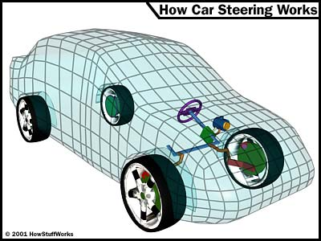
In this edition of HowStuffWorks, we'll see how the two most common types of car steering systems work: rack-and-pinion and recirculating-ball steering. Then we'll examine power steering and find out about some interesting future developments in steering systems, driven mostly by the need to increase the fuel efficiency of cars. But first, let's see what you have to do turn a car. It's not quite as simple as you might think!
Turning the Car
You might be surprised to learn that when you turn your car, your front wheels are not pointing in the same direction.
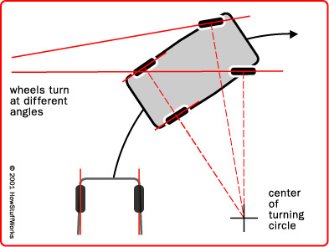
For a car to turn smoothly, each wheel must follow a different circle. Since the inside wheel is following a circle with a smaller radius, it is actually making a tighter turn than the outside wheel. If you draw a line perpendicular to each wheel, the lines will intersect at the center point of the turn. The geometry of the steering linkage makes the inside wheel turn more than the outside wheel.

There are a couple different types of steering gears. The most common are rack-and-pinion and recirculating ball.

Rack-and-pinion Steering
Rack-and-pinion steering is quickly becoming the most common type of steering on cars, small trucks and SUVs. It is actually a pretty simple mechanism. A rack-and-pinion gearset is enclosed in a metal tube, with each end of the rack protruding from the tube. A rod, called a tie rod, connects to each end of the rack.
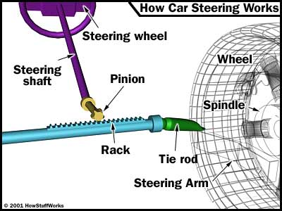
The pinion gear is attached to the steering shaft. When you turn the steering wheel, the gear spins, moving the rack. The tie rod at each end of the rack connects to the steering arm on the spindle (see diagram above).
The rack-and-pinion gearset does two things:
- It converts the rotational motion of the steering wheel into the linear motion needed to turn the wheels.
- It provides a gear reduction, making it easier to turn the wheels.
On most cars, it takes three to four complete revolutions of the steering wheel to make the wheels turn from lock to lock (from far left to far right).
The steering ratio is the ratio of how far you turn the steering wheel to how far the wheels turn. For instance, if one complete revolution (360 degrees) of the steering wheel results in the wheels of the car turning 20 degrees, then the steering ratio is 360 divided by 20, or 18:1. A higher ratio means that you have to turn the steering wheel more to get the wheels to turn a given distance. However, less effort is required because of the higher gear ratio.
Generally, lighter, sportier cars have lower steering ratios than larger cars and trucks. The lower ratio gives the steering a quicker response -- you don't have to turn the steering wheel as much to get the wheels to turn a given distance -- which is a desirable trait in sports cars. These smaller cars are light enough that even with the lower ratio, the effort required to turn the steering wheel is not excessive.
Some cars have variable-ratio steering, which uses a rack-and-pinion gearset that has a different tooth pitch (number of teeth per inch) in the center than it has on the outside. This makes the car respond quickly when starting a turn (the rack is near the center), and also reduces effort near the wheel's turning limits.
Power Rack-and-pinion
When the rack-and-pinion is in a power-steering system, the rack has a slightly different design.
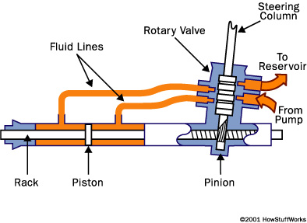
Part of the rack contains a cylinder with a piston in the middle. The piston is connected to the rack. There are two fluid ports, one on either side of the piston. Supplying higher-pressure fluid to one side of the piston forces the piston to move, which in turn moves the rack, providing the power assist.
We'll check out the components that provide the high-pressure fluid, as well as decide which side of the rack to supply it to, later in the article. First, let's take a look at another type of steering.
Recirculating-ball Steering
Recirculating-ball steering is used on many trucks and SUVs today. The linkage that turns the wheels is slightly different than on a rack-and-pinion system.
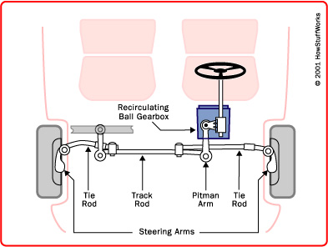
The recirculating-ball steering gear contains a worm gear. You can image the gear in two parts. The first part is a block of metal with a threaded hole in it. This block has gear teeth cut into the outside of it, which engage a gear that moves the pitman arm (see diagram above). The steering wheel connects to a threaded rod, similar to a bolt, that sticks into the hole in the block. When the steering wheel turns, it turns the bolt. Instead of twisting further into the block the way a regular bolt would, this bolt is held fixed so that when it spins, it moves the block, which moves the gear that turns the wheels.
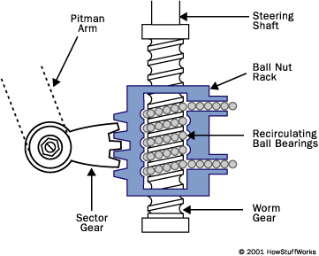
Instead of the bolt directly engaging the threads in the block, all of the threads are filled with ball bearings that recirculate through the gear as it turns. The balls actually serve two purposes: First, they reduce friction and wear in the gear; second, they reduce slop in the gear. Slop would be felt when you change the direction of the steering wheel -- without the balls in the steering gear, the teeth would come out of contact with each other for a moment, making the steering wheel feel loose.
Power steering in a recirculating-ball system works similarly to a rack-and-pinion system. Assist is provided by supplying higher-pressure fluid to one side of the block.
Now let's take a look at the other components that make up a power-steering system.
Power Steering
There are a couple of key components in power steering in addition to the rack-and-pinion or recirculating-ball mechanism.
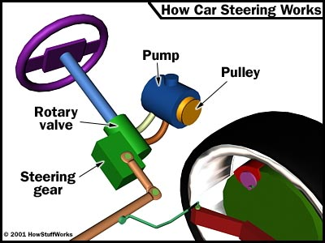
Pump
The hydraulic power for the steering is provided by a rotary-vane pump (see diagram below). This pump is driven by the car's engine via a belt and pulley. It contains a set of retractable vanes that spin inside an oval chamber.
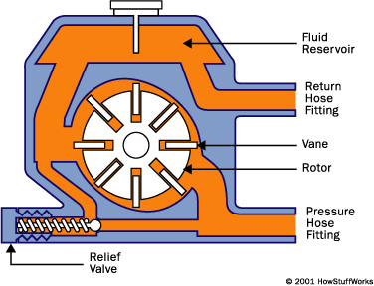
As the vanes spin, they pull hydraulic fluid from the return line at low pressure and force it into the outlet at high pressure. The amount of flow provided by the pump depends on the car's engine speed. The pump must be designed to provide adequate flow when the engine is idling. As a result, the pump moves much more fluid than necessary when the engine is running at faster speeds.
The pump contains a pressure-relief valve to make sure that the pressure does not get too high, especially at high engine speeds when so much fluid is being pumped.
Rotary Valve
A power-steering system should assist the driver only when he is exerting force on the steering wheel (such as when starting a turn). When the driver is not exerting force (such as when driving in a straight line), the system shouldn't provide any assist. The device that senses the force on the steering wheel is called the rotary valve.
The key to the rotary valve is a torsion bar. The torsion bar is a thin rod of metal that twists when torque is applied to it. The top of the bar is connected to the steering wheel, and the bottom of the bar is connected to the pinion or worm gear (which turns the wheels), so the amount of torque in the torsion bar is equal to the amount of torque the driver is using to turn the wheels. The more torque the driver uses to turn the wheels, the more the bar twists.
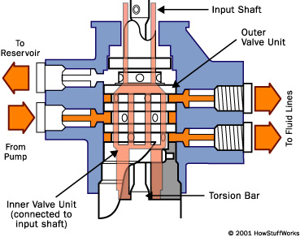
The input from the steering shaft forms the inner part of a spool-valve assembly. It also connects to the top end of the torsion bar. The bottom of the torsion bar connects to the outer part of the spool valve. The torsion bar also turns the output of the steering gear, connecting to either the pinion gear or the worm gear depending on which type of steering the car has.
As the bar twists, it rotates the inside of the spool valve relative to the outside. Since the inner part of the spool valve is also connected to the steering shaft (and therefore to the steering wheel), the amount of rotation between the inner and outer parts of the spool valve depends on how much torque the driver applies to the steering wheel.
When the steering wheel is not being turned, both hydraulic lines provide the same amount of pressure to the steering gear. But if the spool valve is turned one way or the other, ports open up to provide high-pressure fluid to the appropriate line.
It turns out that this type of power-steering system is pretty inefficient. Let's take a look at some advances we'll see in coming years that will help improve efficiency.
The Future of Power Steering
Since the power-steering pump on most cars today runs constantly, pumping fluid all the time, it wastes horsepower. This wasted power translates into wasted fuel.
You can expect to see several innovations that will improve fuel economy:
- Variable-displacement power-steering pump - Some cars already utilize this pump. It reduces the volume of fluid being pumped (thereby reducing the power being used) at higher speeds and when the power steering is not needed.
- Electro-hydraulic systems - The next step would be to use an electric motor to power the steering pump. The speed of the motor can be varied, or the motor can be turned off altogether, to reduce the power consumption.
- Electric power steering - The next step would be eliminating the hydraulics. An electric motor, mounted to the rack, for example, would assist the steering wheel. Sensors on the steering wheel would tell a control system what the driver is doing, and the electric motor would provide assistance accordingly.
- Steer-by-wire systems - Going one step further, these systems would completely eliminate the mechanical connection between the steering wheel and the steering, replacing it with a purely electronic control system. Essentially, the steering wheel would work like the one you can buy for your home computer to play games. It would contain sensors that tell the car what the driver is doing with the wheel, and have some motors in it to provide the driver with feedback on what the car is doing. The output of these sensors would be used to control a motorized steering system. This would free up space in the engine compartment by eliminating the steering shaft. It would also reduce vibration inside the car.
In the past fifty years, car steering systems haven't changed much. But in the next decade, we'll see advances in car steering that will result in more efficient cars and a more comfortable ride.

